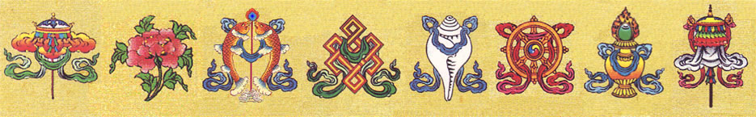

**‘A CONCISE TEACHING ON THE 5 ELEMENTS’**

A Buddhist Upadesha By

Ngakchang Karma Yeshe Namgyal Dorje Rinpoche

For Wesley Evans

Lhabab Duchen, 2021

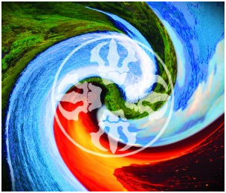

***Five Elements***

***Earth ~ Yellow***

***Water ~ White***

***Fire ~ Red***

***Air ~ Green***

***Space ~ Blue***

**NOTE: THE ABOVE CORRELATIONS TO THE 5 ELEMENTS MAY CHANGE DEPENDING ON MEDITATIONAL SYSTEM (A RARITY)**

From the introduction to MAGIC DANCE (the book you received), by H.H. Dungse Thinley Norbu Rinpoche, my sublime root Lama:

“All limited or limitless spheres of existence which arise, whether gross or subtle, unhappy or happy, ordinary or sublime, depend on the five elements, which are the basis of pure and impure phenomena. Throughout samsara and nirvana, from atoms to insects, human beings and objects and machines, everything is made up of the five elements.”

Wesley,

What follows is some general Buddhist and Western background adapted from Wikipedia. After this propaedeutic, we will begin exploring the beginning of Chapter One of MAGIC DANCE (at the end of page 4) in preparation for our in-person discussion based on H.H. Dungse Thinley Norbu Rinpoche’s book. This includes the dissolution of one’s bodily 5 elements at the time of one’s corporeal demise.

TASHI DELEK

To properly understand the Buddhist Upadesa on the 5 Elements one must first be familiar with the Buddhist view that all phenomena are non-substantial. The Greek word that phenomena is derived from, ‘phanes,’ means ‘to light up’ or ‘illuminate.’ In light of that, consider that all phenomena are non-substantial from the very beginning, that is, they manifest as luminous light… appearing without a permanent, unchanging metaphysical ground or separate “basis.” Thus, the Buddha of this Fortunate Eon, Shakyamuni Buddha, says “Change leads to mental and physical suffering. All phenomena are non-substantial, impermanent and constantly changing.”

The 5 elements, earth, air, water, fire and space are non-substantial. In Theravada Buddhism, the four Great Elements (Pali: *cattāro mahābhūtāni*) are earth, water, fire and air. Mahābhūta is generally synonymous with catudhātu, which is Pāli for the "Four Elements." In early Buddhism, or Theravada, the Four Elements are a basis for understanding that facilitates the transference of one’s mindstream to the far shore of samyaksambuddha, the perfect supreme sublime state of Nirvana, through the unbinding of 'Rupa' or materiality.

In the [Pali canon](https://en.wikipedia.org/wiki/Pali_canon),[[8]](https://en.wikipedia.org/wiki/Mah%C4%81bh%C5%ABta#cite_note-8) the elements are usually identified as four in number but, on occasion, a fifth and, to an even lesser extent, a sixth element may also be identified.

**Four Primary Elements:**

In canonical texts, the four Great Elements refer to elements that are both "external" (that is, outside the body, such as a river) and "internal" (that is, of the body, such as blood). These elements are described as follows:

* **Earth element (*pruṭhavī-dhātu*)**Earth element represents the quality of solidity or attractive forces. Any matter where attractive forces are in prominence (solid bodies) are called earth elements. Internal earth elements include head hair, body hair, nails, teeth, skin, flesh, sinews, bone, organs, intestinal material, etc.[[9]](https://en.wikipedia.org/wiki/Mah%C4%81bh%C5%ABta#cite_note-9)
* **Water element (*āpa-dhātu*)**Water element represents the quality of liquidity or relative motion. Any matter where relative motion of particles is in prominence are called water elements. Internal water elements include bile, phlegm, pus, blood, sweat, fat, tears, nasal mucus, urine, semen, etc.[[10]](https://en.wikipedia.org/wiki/Mah%C4%81bh%C5%ABta#cite_note-10)
* **Fire element (*teja-dhātu*)**  
  Fire element represents the quality of heat or energy. Any matter where energy is in prominence are called fire elements. Internal fire elements include those bodily mechanisms that produce physical warmth, ageing, digestion, etc.
* **Air (or wind) element (*vāyu-dhātu*)**Air element represents the quality of expansion or repulsive forces. Any matter where repulsive forces are in prominence are called air elements. Internal air elements includes air associated with the pulmonary system (for example, for breathing), the intestinal system ("winds in the belly and bowels"), etc

Any entity that carries one or more of these qualities (attractive forces, repulsive forces, energy and relative motion) are called matter (*rūpa*). The material world is considered to be nothing but a combination of these qualities arranged in space (*akasa*). The result of these qualities are the inputs to our five senses, color (*varna*) to the eyes, smell (*gandha*) to the nose, taste (*rasa*) to the tongue, sound ('shabda') to the ears, and touch to the body. The matter we perceive in our mind is just a mental interpretation of these qualities.

* **Space element (*ākāsa-dhātu*)**Internal space elements include bodily orifices such as the ears, nostrils, mouth, anus, etc.
* Consciousness element ([*viññāṇa*](https://en.wikipedia.org/wiki/Vij%C3%B1%C4%81na)*-dhātu*)  
  Described as "pure and bright" (*parisuddhaṃ pariyodātaṃ*), used to cognise the three feelings ([*vedana*](https://en.wikipedia.org/wiki/Vedana)) of pleasure, pain and neither-pleasure-nor-pain, and the arising and passing of the sense contact ([*phassa*](https://en.wikipedia.org/wiki/Phassa)) upon which these feelings are dependent.

While in the Theravada tradition, as well as in the earliest texts, like the Pali Canon, [rūpa](https://en.wikipedia.org/wiki/R%C5%ABpa) (matter or form) is delineated as something external, that actually exists,[[13]](https://en.wikipedia.org/wiki/Mah%C4%81bh%C5%ABta#cite_note-13)[[14]](https://en.wikipedia.org/wiki/Mah%C4%81bh%C5%ABta#cite_note-14)[[15]](https://en.wikipedia.org/wiki/Mah%C4%81bh%C5%ABta#cite_note-15) some of the later schools (like the Nyingmapa) were heavily influenced by the Yogacara or Mind Only tradition. “Rūpa” means both materiality and sensibility—it signifies, for example, a tactile object both insofar as that the object is tactile and that it can be sensed. In some of these schools, rūpa is not a materiality which can be separated or isolated from cognizance; such a non-empirical category is incongruous in the context of some schools of Mahayana and Vajrayana Buddhism. **In the Yogacara view, rūpa is not a substratum or substance which has sensibility as a property.** For this school, rūpa functions as perceivable physicality and matter. Another way to say this: rūpa is defined in its function; what it does, not what it is.[[16]](https://en.wikipedia.org/wiki/Mah%C4%81bh%C5%ABta#cite_note-16)

As such, the four great elements are conceptual abstractions drawn from the emergent sensorium. They are sensorial typologies, and are not metaphysically materialistic.[[17]](https://en.wikipedia.org/wiki/Mah%C4%81bh%C5%ABta#cite_note-17) From this perspective, they are not meant to give an account of matter as constitutive of external, mind-independent reality. This view is the epistemological starting point for Nyingmapa (Ancient Ones) school of Vajrayana Buddhism that I am a lineage holder for and Isaac’s practice tradition.

Your book, MAGIC DANCE, is written by H.H. Dungse Thinley Norbu Rinpoche, my sublime root Lama. H.H. Dungse Thinley Norbu Rinpoche’s father was H.H. Dudjom Rinpoche II, Jigdral Yeshe Dorje (from whom you received the meditation instructions on stillness, movement, and awareness). H.H. Dudjom Jigdral Yeshe Dorje Rinpoche was the immediate reincarnation of Heruka/Traktung Dudjom Lingpa, who created the Dudjom Tersar (New Treasures of Dudjom) Nyingma lineage which holds the transmission that promulgates this view of the 5 elements as the display of the ineffable basis of reality.



*AH*

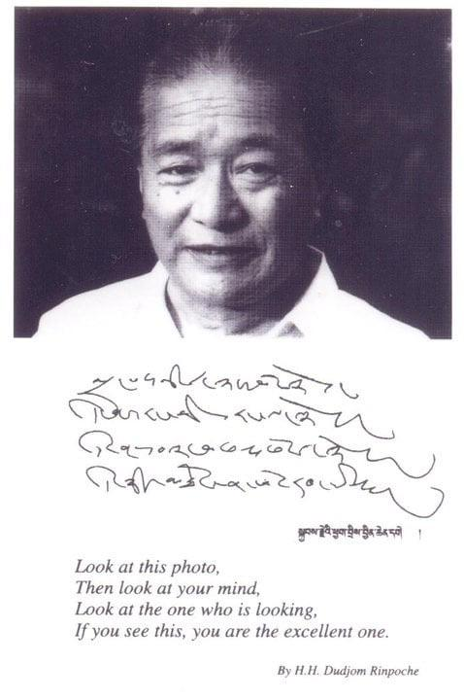

*H.H. Dudjom Jikdral Yeshe Dorje Rinpoche*

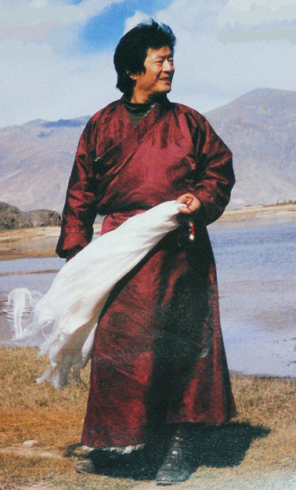

*H.H. Dungse Thinley Norbu Rinpoche*

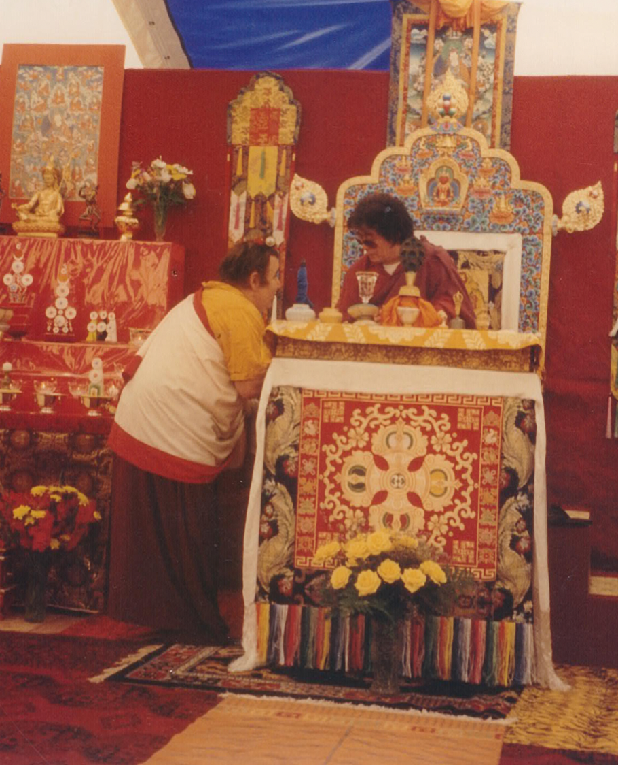

*Ngakchang Karma Yeshe Namgyal Dorje Rinpoche*

*making offerings to*

*H.H. Dungse Thinley Norbu Rinpoche*

MAGIC DANCE: